**Cloud Connector Configuration**

**Table of Contents**

**1.** **Steps to install cloud connector** 4

Pre-requisites: 4

**2.** **To connect on premise ECC system with cloud platform using cloud connector** 8

# **Steps to install cloud connector**

## Pre-requisites:

* Make sure, you have the latest version of Java installed in your system.
* Jvm/Jre should be up to date.

Open the SAP Cloud Connector URL in your Google Chrome.

<https://tools.hana.ondemand.com/#cloud>

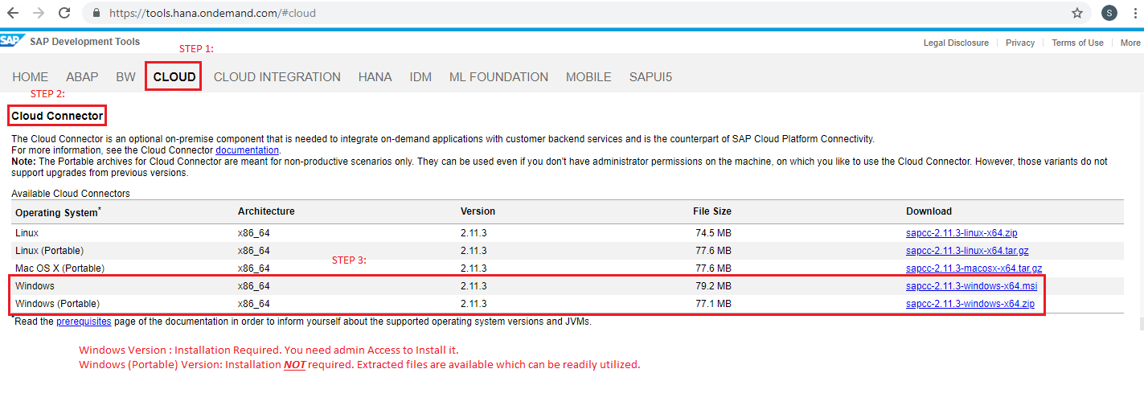

Step 1: Click on CLOUD.

Step 2: Scroll down to Cloud Connector

Step 3: From download, click on Windows (Portable) sapcc-2.11.3-windows-x64.zip

**Note**: 2.11.3 version is the latest as on Feb 2019. SAP might update the versions quarterly.

**Important Point:**

Usage of .msi version of Cloud Connector is recommended in real time projects. For practice purpose, to install the cloud connector on laptop/desktop, we are using portable version.

Step 4: Once cloud connector is downloaded, unzip the file, sapcc-2.11.3-windows-x64.zip

Step 5: Open the unzip folder.

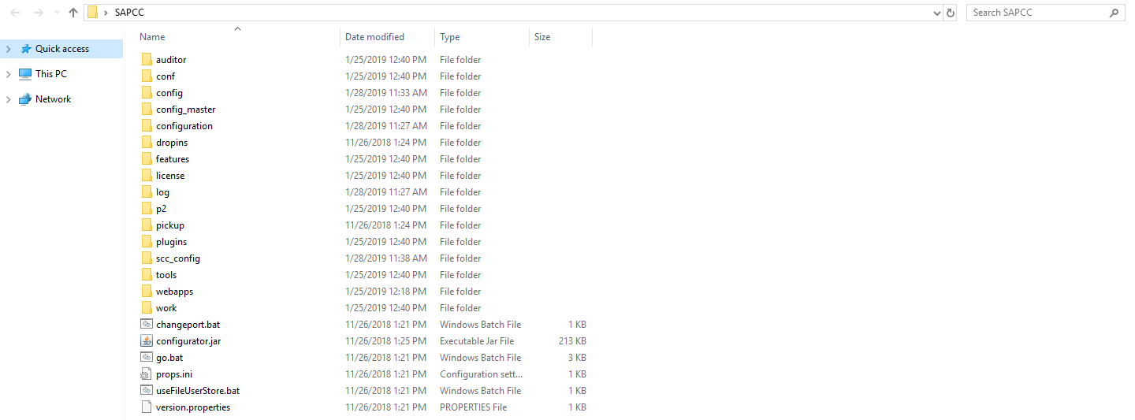

Step 6: double Click on go.bat file from the list of files

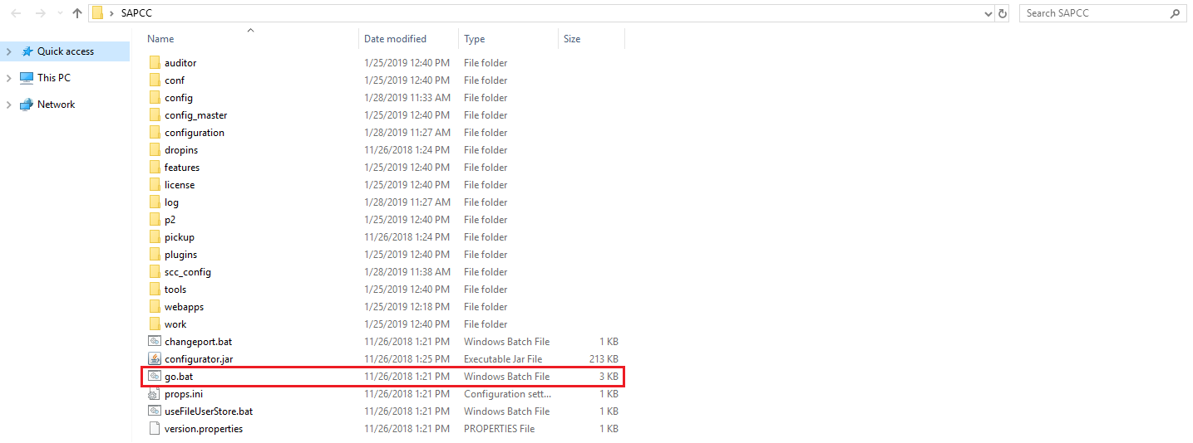

Step 7: Below Screen appears. It is mandatory that this screen should be open throughout our session.

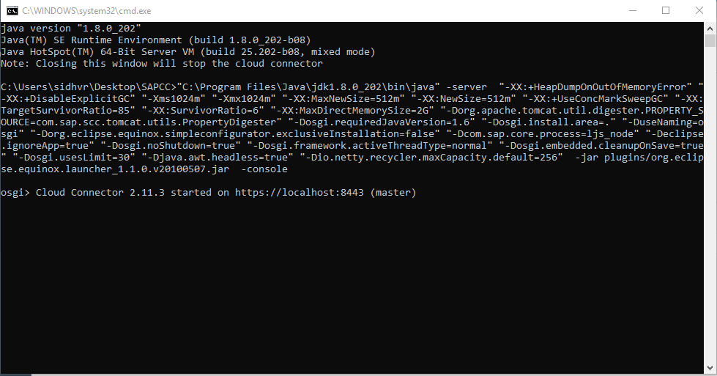

Step 8: Once go.bat is started, go to google chrome and type the below URL.

<https://localhost:8443>

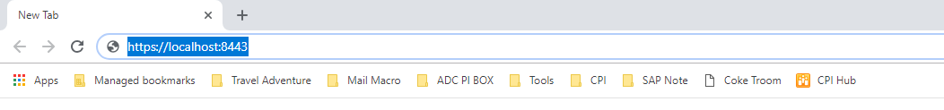

Step 9: An error page saying connection is not private will appear, Click on Advanced button and then proceed to unsafe

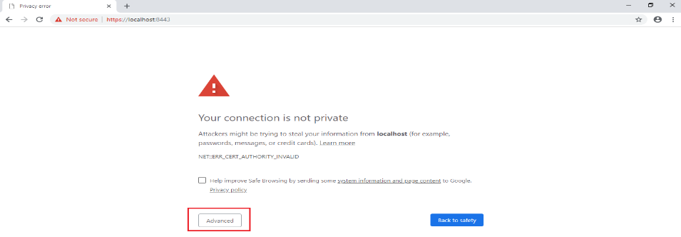

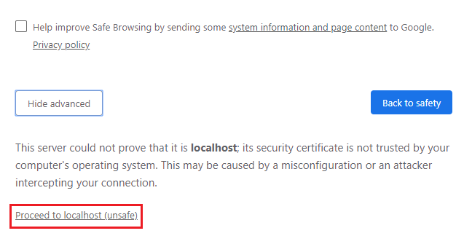

Step 10: Once you are done with Step 9, you will be re-directed to the below window.

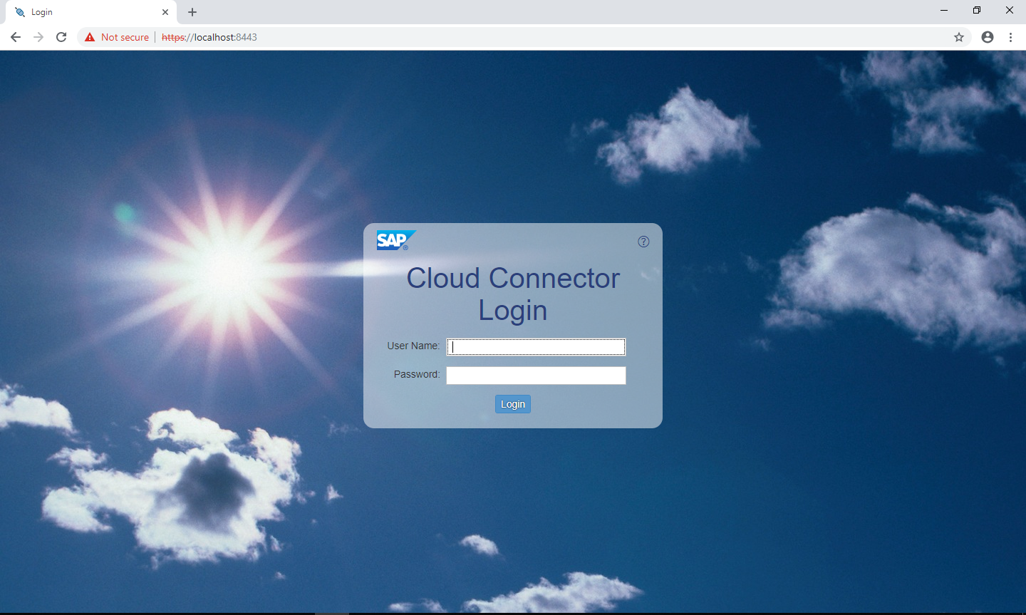

Step 11: For the First time login, use the following credentials

User Name: Administrator

Password: manage

Step12: Choose the Installation type



Step 13: Now, we have to change the password

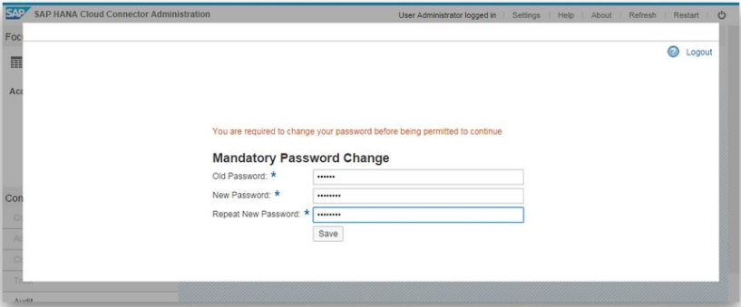

Step 14: Click on Add Sub Account in top right corner



Step 15: Fill in the details

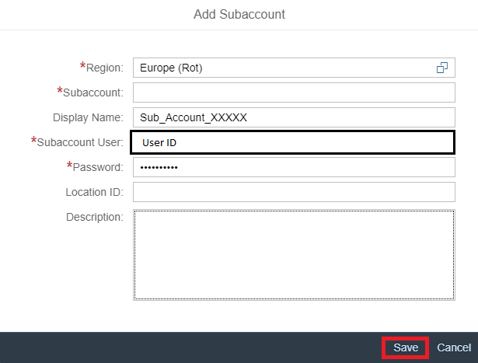

Account will be displayed like below.

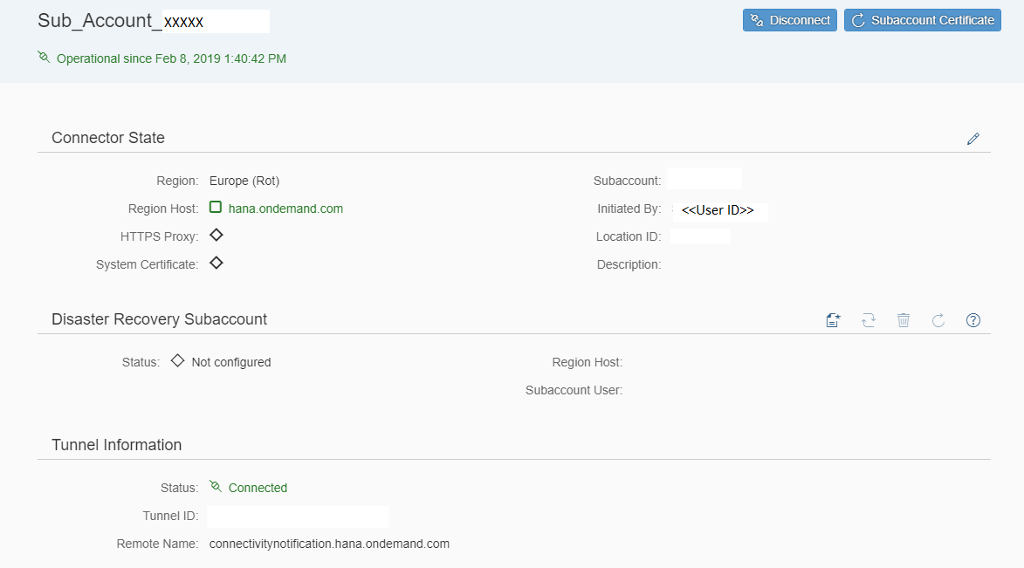

**Now Cloud Connector is ready.**

# **To connect on premise ECC system with cloud platform using cloud connector**

Step 1: Click on Cloud to On-premise tab in the sub-account created

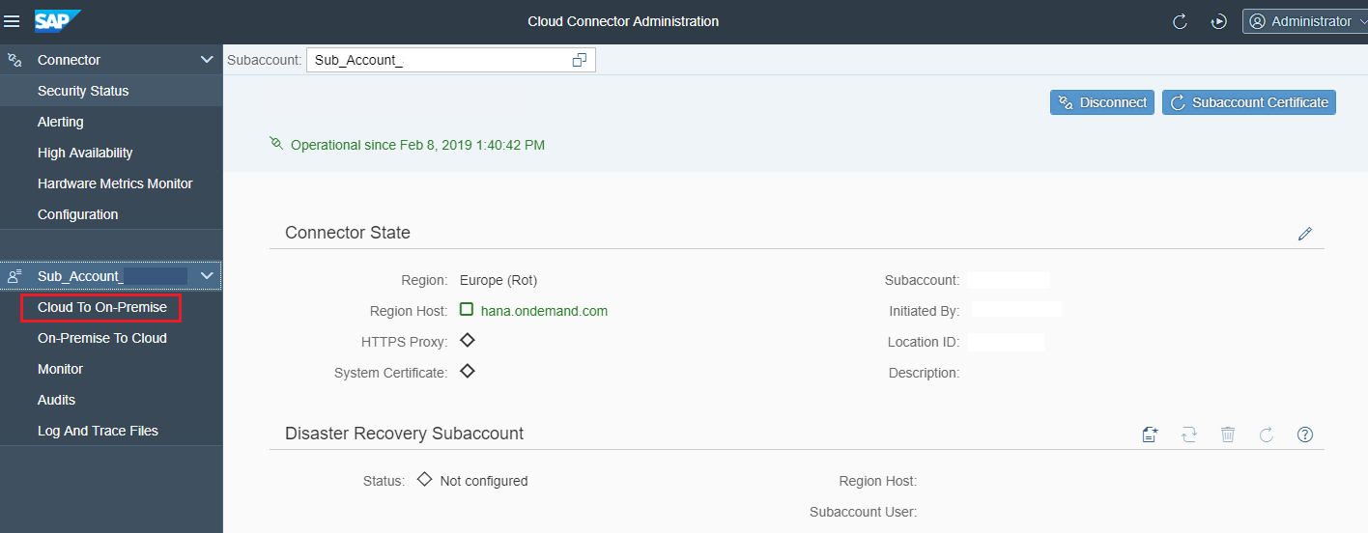

Step 2: Access Control Tab ---> Mapping Virtual to Internal System ----> “+” button

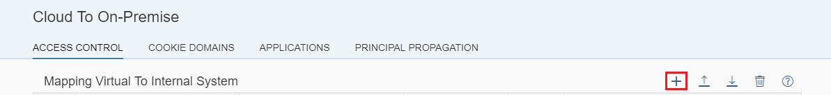

Step 3: Choose the backend type as ABAP System and click next.

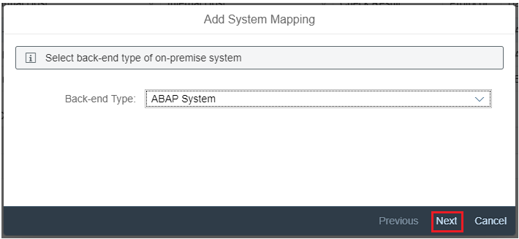

Step 4: Choose Protocol as HTTP and click on next

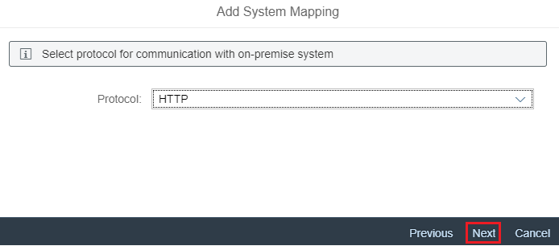

Step 5: Enter the Internal host of the On Premise System and click next

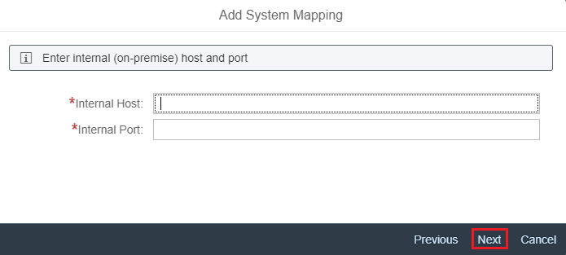

Step 6: Enter the Virtual Host (optional)

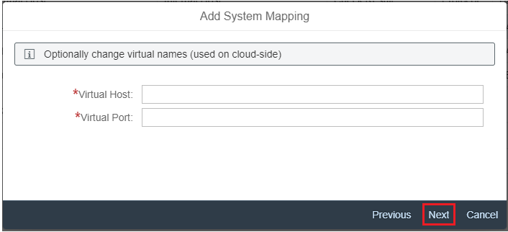

Step 7: Principal Type “None”

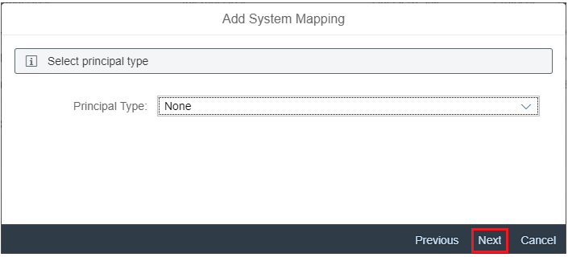

Step 8: Add description if required and click next

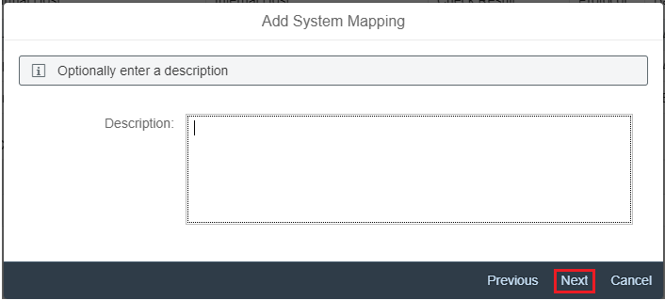

Step 9: Click on “Check Internal host” and click on finish

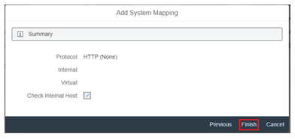

Step 10: Once done, click on Availability check button under Actions tab. If all connections are good, Check Result will be displayed as Reachable

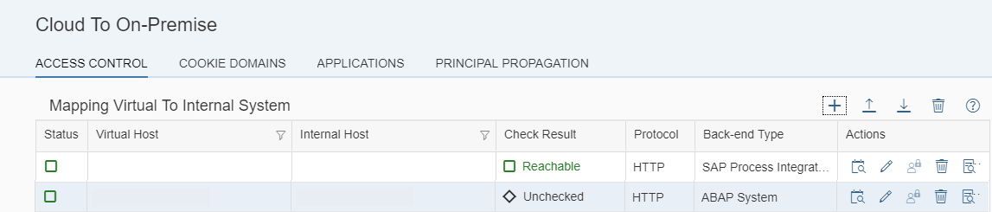

Step 11: Now, to make all resources accessible on premise, we need to configure the resources.

Click on “+”

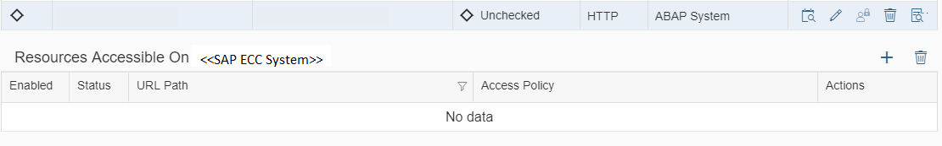

Step 12: add the below parameters in the Add resource tab and click on Save

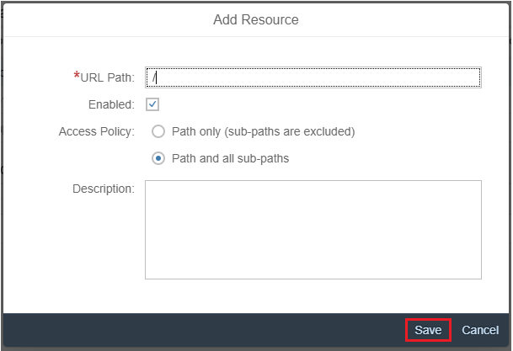

Step 13: Now your Resource paths are also added.

